SEC/FIF FOIA BRIEF
SUMMARY: The recent MMTLP FOIA release disclosed emails and meetings between SEC officials, including Erik Gerding and David Saltiel, and Howard Meyerson of the Financial Information Forum, in which FIF lobbied to influence the review of Next Bridge Hydrocarbons' Subscription Rights registration by claiming the FINRA trading halt created unrecoverable loaned shares, contradicting official assertions that no such damages occurred.
BACKGROUND:
➢ FINRA halted trading of MMTLP on December 9, 2022, two days before the publicized and promoted end of trading on December 12, 2022.
➢ Investors who planned to sell their shares of MMTLP on December 9th and 12th have been trapped, with assets frozen for over 1100 days.
➢ On July 26, 2023, Next Bridge Hydrocarbons (NBH, non-trading company that assumed the oil and gas assets represented by the MMTLP dividend as part of their spin-out transaction) filed a S-1 Registration for Subscription Rights offering that incentivized shareholders to transfer their shares to NBH’s transfer agent. A strategy with the potential to reveal uncertificated share obligations created via share lending and short selling.
https://cdn.prod.website
files.com/6169e69d0075ec7c66221a8b/64c169a2b6b66477cca6fe17_Next%20Bridge%20Hydroca rbons%20Press%20Release%20S-1%20Filing%20vFINAL%207-26-23.pdf
➢ NBH withdrew their Subscription Rights Offering at the request of the SEC on February 8, 2024. https://cdn.prod.website
files.com/6169e69d0075ec7c66221a8b/65c4fc6719f5a246d32e6059_NBH%20-
%20Press%20Release%20(Withdrawal)%20Exhibit%2099.1%20vF%202-8-24.pdf
➢ The SEC/FIF FOIA records detail communication that occurred between SEC and FIF between the
time when NBH filed for their Subscription Rights Offering and when NBH withdrew the offering at
the request of the SEC.
FOIA BREAKDOWN AND ANALYSIS:
FIG. 1 – September 19, 2023: Howard Meyerson, FIF Managing Director, emails senior SEC officials Erik Gerding, SEC Director of Division of Corporate Finance, David Saltiel, SEC Director of Trading & Markets, and Sai Rao, General Counsel for Division of Trading & Markets.
➢ Meyerson used the terms “some of our members” and “group” indicating multiple brokers.
➢ Meyerson indicated his members’ concern regarding NBH’s Subscription Rights Offering.
➢ Meyerson acknowledged he is unaware of a comment process for SEC filings but asked for his members to give input anyway.
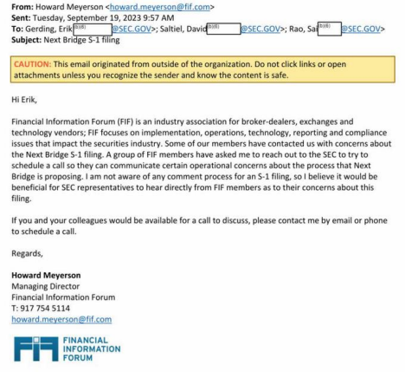FIG. 1
FIG. 2 – September 23, 2023: Saltiel responds to Meyerson request for a meeting.
➢ Saltiel offered to engage with Meyerson’s FIF members on “operational issues” rather than the specifics of an issuer’s registration disclosures.
➢ Saltiel requested to know what specific topics FIF members wanted to discuss and asked Meyerson to suggest times for a meeting.
➢ Saltiel attempted to dissuade communications regarding NBH’s registration statement, as such conversations were/are inappropriate and against SEC policy, but opened the door for a meeting anyway.
➢ John Pochilo, SEC Advisor to the Director of the Division of Trading and Markets, was copied on the email.
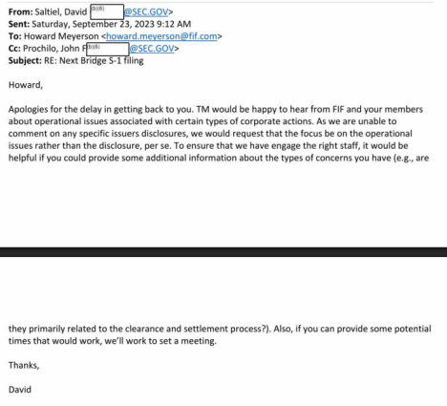FIG. 2
FIG. 3 – October 2, 2023: Meyerson proposes two dates the next week for his members to meet with Saltiel and other representatives from SEC.
➢ Meyerson indicated he will send Saltiel “an outline of the points FIF members would like to raise during the call.”
➢ John Pochilo, SEC Advisor to the Director of the Division of Trading and Markets, and Kevin McCabe, FIF Program Director, were copied on the email.
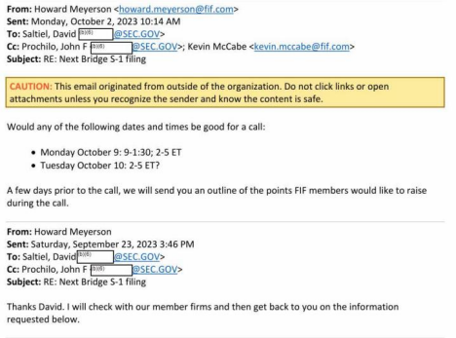FIG. 3
FIG. 4 – October 4, 2023: Meyerson forwarded to Saltiel 7 points for discussion at their upcoming meeting. Despite warnings from Saltiel, FIF members attempted to influence the SEC's examination of NBH’s registration statement.
➢ POINT 1: “Participating customers are forced to transfer shares held in their IRA accounts (by trustees that qualify under IRC §408 (a)(2)) out of these accounts, resulting in adverse tax consequences.”
o The Subscription Rights Offering was OPTIONAL. Shareholders were NOT FORCED to participate. FIF Members feigned concern over tax implications. The only potential tax
implications were for QUALIFIED accounts (401(k), IRAs, etc.). FIF showed their card. Open short OBLIGATIONS are shielded from exposure in qualified investor accounts.
➢ POINT 2: “Participating customers lose the protections of SEC Rule 15c3-3.”
o FIF members were not concerned about customer protections under SEC Rule 15c3-3, which governs custodial protections of shares, as they admit in “Point 4” they are clearly in violation of the rule. They cannot recall lent shares. Tradestation admitted openly to customers in an email dated November 2023, that they could not recall shares and therefore, could not fulfill client’s requests to transfer shares to the transfer agent as those shares were not backed by certificates.
➢ PONT 3: “Transfer agents are not staffed to handle the functions required by the Next Bridge Proposal.”
o Transfer agents are hired by issuers to “maintaining accurate records of registered shareholders, including names, addresses, and the number of shares owned,” and “handling the issuance, transfer, and cancellation of stock certificates to reflect changes in ownership, such as when shares are bought, sold, inherited, or gifted.”
o It would stand to reason that Next Bridge consulted with their transfer agent to ensure the orderly transfer of shares.
o Both DJT and GME have recently issued benefits for shareholders who transfer their shares to the transfer agent.
➢ POINT 4: “Because of the prior FINRA trading halt, there are shares on loan that broker-dealers cannot recover.”
o This is seemingly an admission of the FIF members’ motive in requesting INAPPROPRIATE communications with the SEC regarding an issuer’s registration statement. They cannot recover lent-out shares; therefore, they cannot deliver certificated shares to the transfer agent. This is a violation of SEC Rule 15c3-3.
➢ POINT 5: “If the SEC approves the S-1 filing as proposed, lending broker-dealers will not be able to recover these shares (or the equivalent warrants) on behalf of customers.”
o FIF Members admitted that they cannot transfer customers’ shares to the transfer agent, because they cannot recover lent out shares. They do not have certificated shares because they sold or lent more shares than certificates.
o If the SEC approved the S-1, more broker-dealers would have been exposed in addition to Tradestation.
➢ POINT 6: “Approving the filings as proposed would not be consistent with the SEC’s long-standing three-part mission to “protect investors, maintain fair, orderly, and efficient markets, and facilitate capital formation.”
o FIF members seemingly attempted to influence the SEC to interfere in Next Bridge Hydrocarbons’ registration statement, against policy, and out of fear of exposure, by invoking the SEC’s mission.
o Clearly, FINRA’s U3 halt, its aftermath, and the SEC’s alleged participation in the cover-up did not uphold investor protection or the integrity of the US Capital Markets.
➢ POINT 7: “Recommendation: If the SEC decides to approve the S-1 filing, the SEC should require removal of the provision that participating customers cannot hold shares through a bank, broker dealer or other nominee; this will maintain customer choice (whether or not to hold through an intermediary), protect customer that would be disadvantaged by such transfer, and allow for future reconciliation of outstanding stock loans (or equivalent warrants).”
o FIF Members once again revealed the path to discovering outstanding share OBLIGATIONS…QUALIFIED ACCOUNTS!
o Broker-Dealers asked SEC to require NBH to remove provision requiring transfer of shares to the transfer agent in hopes that they evade discovery of uncertificated OBLIGATIONS in 401k and IRAs.
o These communications and their enclosed requests were inappropriate and against long
standing SEC policies. Both parties acknowledged this and proceeded anyway.
o Consequently, Next Bridge Hydrocarbons announced they withdrew their S-1 Subscription
Rights Registration Statement at the request of the SEC on February 8, 2024. NBH was
unaware at the time of communications between the SEC with FIF Leadership and its members.
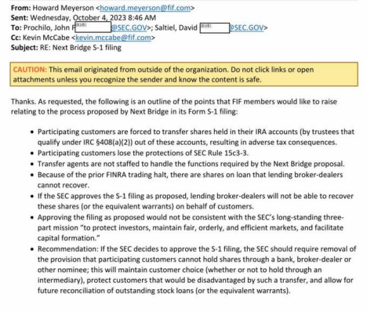FIG. 4
FIG. 5 – October 20-23, 2023: Saltiel sends post-meeting, follow-up questions to Meyerson.
➢ Saltiel indicated the meeting with FIF Members did occur (despite the acknowledged and clearly inappropriate agenda).
➢ Saltiel’s questions indicated during the meeting the FIF Members disclosed they were in contact with FINRA.
➢ Meyerson told Saltiel that none of the FIF Members were “able” [refused] to tell the SEC who they were speaking with at FINRA.
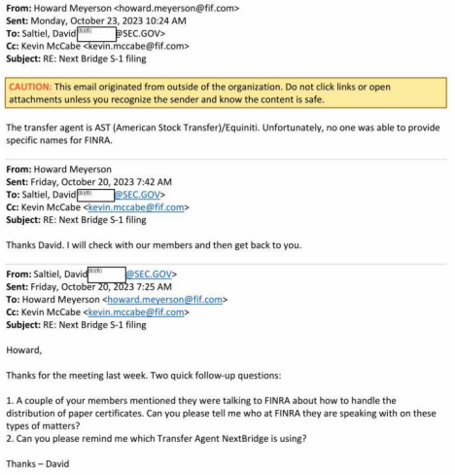FIG. 5
SUMMARY:
The FOIA records from the SEC and FIF reveal concerns raised by FIF members about the registration statement for Next Bridge Hydrocarbons' Subscription Rights. These documents highlight communications that appear to show attempts by FIF members to influence the SEC's review process, potentially contravening established SEC policies against external interference in examinations. Additionally, the records include acknowledgments from FIF participants regarding the holding of uncertificated obligations
in investors' 401(k) and IRA accounts, which may violate SEC Rule 15c3-3 (customer protection rules) and Regulation SHO (short sale close-out requirements). MMTLP investors were not safeguarded by FINRA's U3 trading halt, leading to unresolved settlement issues. Evidence suggests coordination among FIF members, the SEC, and possibly FINRA to withhold information related to potential regulatory violations and harms to investors. This alleged collusion has reportedly impeded Next Bridge Hydrocarbons' efforts to deliver shareholder value, secure funding, and maintain sound corporate governance practices.

