AMC: Apparently, the “Coincidence” Filed Regulatory Paperwork
Tonight, I am not presenting another theory constructed from a price chart, a mysterious screenshot, three red arrows and somebody yelling, “Trust me, bro.” I am presenting a documented market-structure pathway that was operational during AMC’s historic 2021 run. Every major step comes from a public record: the governing FTX and CM-Equity product documents, CM-Equity’s financial and best-execution reports, Interactive Brokers’ Rule 606 routing data, Citadel Securities’ Rule 605 execution report and the SEC’s historical failure-to-deliver files. Apparently, the “coincidence” finally made the mistake of filing paperwork.
The starting point is simple. FTX offered customers a product whose value followed AMC’s stock price. It looked like a tokenized AMC share on the screen, but the governing documents described it as a bilateral, cash-settled over-the-counter derivative manufactured by CM-Equity, with CM-Equity acting as the sole counterparty. In plain English, customers were not buying ordinary AMC shares with voting and delivery rights. They were buying contracts tied to AMC’s value, and CM-Equity was legally responsible for the resulting payment obligation. FTX operated the digital storefront, but CM-Equity stood behind the counter. Calling it a “tokenized stock” was apparently more attractive than saying, “You bought a private derivative contract tracking a stock you do not actually own.” Funny how the boring legal language becomes important after the confetti stops falling.
That obligation created financial risk. If AMC’s price moved sharply, CM-Equity still had to satisfy the contracts it issued. Companies commonly manage that exposure by acquiring assets or derivatives that offset what they may owe customers. This is where the pathway moves beyond speculation. CM-Equity’s 2021 management reporting stated that its trading book increased by roughly €20 million, largely because it acquired hedge positions for liabilities arising from bilateral mass-customer contracts. That statement does not identify AMC individually, but it establishes something critical: CM-Equity did not merely possess the theoretical ability to hedge this class of products. It reported maintaining actual hedge positions against these customer liabilities.
We then followed that activity to the next door. CM-Equity’s 2021 best-execution report identified Interactive Brokers Central Europe as the dominant gateway for approximately 95.28 percent of its reported equity volume and approximately 98.95 percent of its reported equity-derivative volume. That does not prove Interactive Brokers handled those percentages of CM-Equity’s AMC business specifically. It means that Interactive Brokers overwhelmingly handled CM-Equity’s trading within the relevant reported categories. This was not an obscure side road buried at the bottom of a broker list. This was the highway.
Interactive Brokers’ United States Rule 606 report for the second quarter of 2021 identified Citadel Securities, under the routing code CDRG, as an execution destination for the broad category called “other NMS stocks,” which included AMC because it was not an S&P 500 security. Because Rule 606 aggregates multiple customers and securities, it cannot tell us whether a particular CM-Equity AMC hedge order reached Citadel. Think of the report as a traffic map: it proves that the Interactive Brokers highway had an open Citadel exit receiving traffic during the relevant period. What it does not reveal is the license plate on CM-Equity’s car.
Citadel’s June 2021 Rule 605 report makes that exit much harder to dismiss as irrelevant. It records approximately 3.11 million covered AMC orders representing approximately 1.611 billion shares during June. Approximately 954.2 million covered-order shares were reported as executed at Citadel, approximately 648.4 million were canceled and roughly 8.3 million were executed elsewhere. Precision matters: Citadel did not report executing 1.611 billion AMC shares on June 2. That figure represents covered orders submitted throughout June, while approximately 954.2 million shares were reported executed at Citadel during the month. The accurate number is already extraordinary. It does not need steroids, a cape or an internet rumor attached to it.
The settlement record adds another documented piece. In 2021, ordinary U.S. stock transactions generally settled on T+2. The SEC’s aggregate AMC failure-to-deliver balance was approximately 1.4 million shares on June 4, the expected settlement date for trades executed on June 2. AMC’s aggregate fail balance later exceeded four million shares on June 21, June 25 and June 30, and AMC appeared on the NYSE threshold securities list. Those were real settlement problems, but the public SEC data combine obligations across clearing members. They do not identify Citadel, Interactive Brokers, CM-Equity or a particular customer as responsible for any individual failure.
That limitation does not destroy the pathway. It defines the investigation. We are no longer asking whether “something strange” happened to AMC. We can ask a narrow, testable question: did any CM-Equity hedge order, FTX-related AMC exposure or associated settlement obligation enter the Interactive Brokers system and reach Citadel, a Citadel-connected venue or an account connected to that activity?
Answering that question requires customer-level records: CM-Equity’s Interactive Brokers trade confirmations, account statements and hedge sub-ledger; the FTX product-liability ledger; Interactive Brokers’ order identifiers; CAT lifecycles; Citadel blue sheets; and NSCC and DTC settlement records. Those documents could connect the originating account, security, order, execution venue and final delivery obligation. They would replace the traffic map with the license plate.
The public record does not yet prove a Citadel crime or identify the party responsible for a specific failed delivery. What it establishes is a documented pathway, an extraordinary concentration of AMC order activity, an elevated settlement-failure cluster and a clearly defined evidentiary gap. We found the pipe. We identified the doors it passed through. What remains is the transaction-level key showing who opened the final door.
To understand why that door matters, we must begin where the obligation began: with the “AMC stock” FTX marketed that, according to its own governing paperwork, was not an ordinary AMC share at all.
Apparently, the Token Had a Hedge Book and the Highway Had a Citadel Exit
Five evidence upgrades materially narrow the AMC tokenized-equity investigation. The inquiry is no longer whether Citadel’s name appears inside a blockchain. The customer-facing token could exist on-chain while the financial exposure was managed off-chain through contracts, brokerage accounts, hedge positions, market makers and the United States settlement system. Apparently, calling something “on-chain” was supposed to make everyone forget to inspect what happened off-chain.
The breakthrough came from James Allen’s decision to stop treating the FTX token as the end of the pathway. The better question was: Who legally owed the customer money when the AMC-linked contract changed value? From there, the investigation could follow the liability into the traditional financial system: who carried the exposure, whether it was hedged, which broker handled the activity, where the orders could have been executed and which entity ultimately owed delivery.
The first evidence upgrade identifies what FTX actually sold. The governing FTX and CM Equity product document describes the AMC instrument as a bilateral, cash-settled over-the-counter derivative manufactured by CM Equity, with CM Equity serving as the sole counterparty. The customer did not own ordinary AMC common stock, receive shareholder rights or possess the contractual right to demand delivery of an AMC share. [S1] FTX displayed and facilitated the product, but CM Equity carried the legal payment obligation. The token wore the AMC costume. The derivative contract performed the legal work.
That does not prove fraud or establish that the product harmed AMC. It establishes the legal starting point. If AMC’s price rose, CM Equity’s potential liability could rise with it, creating exposure that required risk management.
The second evidence upgrade supports actual hedge activity. A reproduction of CM Equity’s 2021 management report states that its trading book increased by approximately €20 million, largely because hedge positions were acquired for liabilities arising from bilateral mass-customer contracts. [S3] This moves the evidence beyond contractual permission to hedge: CM Equity reported acquiring hedge positions for this class of liability.
The report does not identify the individual securities inside that inventory or attribute the full €20 million increase to AMC. It also does not reveal whether any AMC-related hedge used shares, options, swaps, futures, baskets or another instrument. A certified Bundesanzeiger copy should be obtained before relying on the reproduction in litigation. The accurate conclusion is that CM Equity’s reporting supports actual hedge activity for bilateral customer liabilities, while the composition of the hedge remains a transaction-level question. Apparently, the hedge fairy existed. She just kept the account statement.
The third evidence upgrade identifies the dominant brokerage gateway. CM Equity’s 2021 MiFID best-execution report states that Interactive Brokers Central Europe handled approximately 95.28 percent of its relevant reported equity volume and 98.95 percent of its reported equity-derivative volume. [S2] Those are aggregated categories, so they do not prove that Interactive Brokers handled 95.28 percent of CM Equity’s AMC hedging. They establish that Interactive Brokers was overwhelmingly CM Equity’s principal gateway for the categories most capable of containing such a hedge. This was not a random side street CM Equity might have used once. It was the interstate.
The fourth evidence upgrade follows that interstate into the United States routing system. Interactive Brokers’ second-quarter 2021 Rule 606 report lists Citadel Securities, identified by routing code CDRG, as an execution destination for the aggregated category “other NMS stocks.” AMC belonged to that category because it was not an S&P 500 security. During June 2021, Citadel received approximately 1.86 percent of Interactive Brokers’ routed orders in that category. [S4–S5]
Rule 606 functions as an aggregated traffic report. It identifies destinations receiving broker order flow but does not disclose every customer, originating account or security routed to those destinations. It therefore confirms that the Citadel exit existed, was operational and received Interactive Brokers order flow during the relevant period. It does not prove that a CM Equity AMC order took that exit. The highway is confirmed. The exit is confirmed. The license plate remains concealed.
The fifth evidence upgrade establishes Citadel’s security-specific AMC activity. Citadel’s June 2021 Rule 605 file reports approximately 3.11 million covered AMC orders representing approximately 1.611 billion submitted shares. Of those, approximately 954.2 million covered-order shares were executed at Citadel, 648.4 million were canceled and 8.3 million were executed elsewhere. [S6–S7]
Those numbers cover the entire month of June, not June 2 alone. They are not a count of unique AMC shares or proof that every submitted share created a new economic position. Orders can be canceled, replaced or routed elsewhere. Rule 605 also does not identify the customer, originating broker, order direction, beneficial owner, hedging purpose or trader’s intent.
What it establishes is still substantial: Citadel possessed the infrastructure and actual AMC activity necessary to process enormous covered-order volume during the month under investigation. The report identifies AMC but cannot identify CM Equity or FTX. Apparently, the public may learn that nearly one billion covered-order shares were executed at Citadel, but asking whose orders they were is where the curtains suddenly close.
Settlement evidence adds the final public layer. In 2021, ordinary United States equity trades generally settled on T plus 2, meaning a trade executed Wednesday, June 2 would ordinarily settle Friday, June 4. The SEC reported approximately 1.4 million aggregate AMC failures to deliver on June 4. AMC’s aggregate fail balance later exceeded four million shares on June 21, June 25 and June 30, and AMC appeared on the NYSE threshold securities list. [S8]
An FTD means securities required for settlement were not delivered by the settlement date. The SEC figure represents the aggregate outstanding balance associated with AMC on that date. It is not necessarily the number of new failures created that day and does not identify the clearing member, customer or originating transaction. The late-June balances also cannot automatically be traced to June 2 trades. They establish unresolved aggregate delivery obligations, not proof of naked short selling, manipulation or Citadel’s responsibility.
Each public record therefore answers a different part of the investigation while withholding the identifier needed to connect the parts. The FTX document identifies the contract and legal counterparty. CM Equity’s management reporting supports actual hedge activity for that class of liability. Its best-execution report identifies Interactive Brokers as the dominant gateway. Interactive Brokers’ Rule 606 report confirms Citadel as an available execution destination. Citadel’s Rule 605 report establishes its enormous security-specific AMC footprint. The SEC’s FTD data document settlement stress.
What remains missing is the customer-level key connecting a CM Equity account to a particular AMC hedge order, an Interactive Brokers routing decision, a Citadel execution and a final NSCC or DTC delivery obligation. Visual 1 shows both the pathway the evidence now establishes and the exact link the public records still cannot prove.
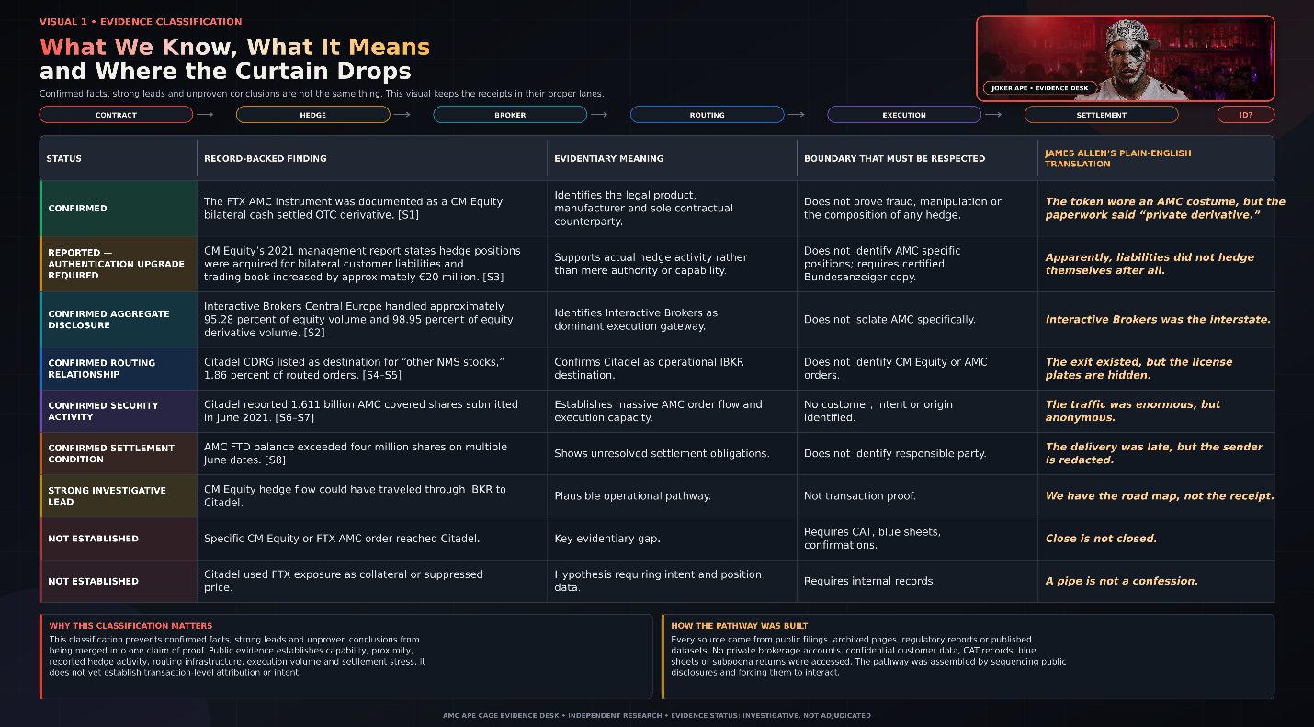
Visual 1 establishes the evidentiary classification. The next question is how those classifications were reached. A conclusion is only as reliable as the record supporting it, the method used to obtain that record and the limits imposed by what the record does not disclose.
No single document establishes the complete pathway. The FTX and CM Equity product document identifies the legal obligation but not the hedge. CM Equity’s reporting supports hedge activity and identifies its dominant broker but not an AMC-specific transaction. Interactive Brokers’ Rule 606 data confirm Citadel as an operational routing destination but conceal the originating customer and security. Citadel’s Rule 605 file identifies enormous AMC activity but not the source of the orders. The SEC’s FTD data document settlement stress but not the participant responsible.
The investigation’s originality therefore does not depend on one secret document. It comes from placing separate public records in the correct sequence without pretending that one record proves what only another could establish. Each source contributes one portion of the pathway, and each stops just before providing the identifier needed to connect it to the next.
That makes the source trail part of the evidence. Visual 2 identifies how each public record was accessed, what information was extracted and the precise role it plays in the investigation. No secret database. No anonymous tipster. Just public records that apparently forgot to coordinate their alibis.
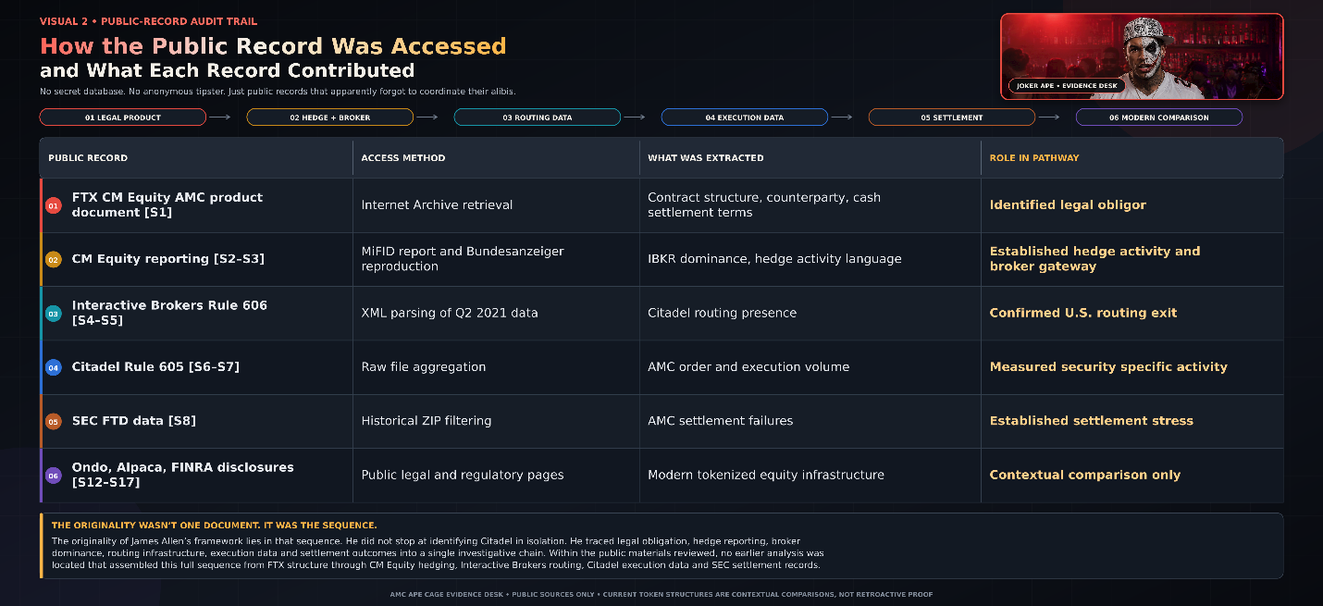
The modern Ondo, Alpaca and Citadel-related environment remains a separate comparison. It may demonstrate how tokenized equities interact with regulated brokerage, execution and settlement infrastructure today. It does not retroactively prove what occurred in 2021. The 2021 allegation must stand or fall on 2021 records.
The central investigative question can now be stated precisely: Can a CM Equity originating account, an FTX-related AMC liability or a corresponding hedge instruction be connected through Interactive Brokers order identifiers to a Citadel execution and then to an NSCC or DTC settlement entry?
That question is answerable with the right records. A CM Equity trade confirmation or account statement, a CAT order lifecycle, a regulatory blue sheet or a clearing record could complete the chain. Those records are not public, and this report does not claim access to them. The public evidence establishes the architecture, not the final transaction-level linkage.
We found the manufacturer. We found the legal liability. We found reported hedge activity. We found the dominant broker. We found the routing exit. We found Citadel’s AMC execution footprint. We found the settlement stress. What remains is the customer-level key that turns a documented structure into attribution.
With the pathway mapped and its evidentiary boundaries clearly marked, the investigation now moves from architecture to traffic: Citadel’s June 2021 AMC covered-order footprint, the T-plus-2 settlement cycle, the failure-to-deliver cluster and the chronology that only transaction-level records can fully resolve.

Apparently, the Token Did Not Teleport: The 2021 Operational Pathway
The public evidence supports a six-stage operational pathway connecting FTX’s customer-facing AMC product to the traditional financial infrastructure capable of hedging, executing and settling the resulting exposure. The pathway runs from FTX to CM Equity, from CM Equity’s reported hedge activity to Interactive Brokers, from Interactive Brokers into a United States routing environment that included Citadel, and finally into the clearing and settlement systems operated by NSCC, DTC or OCC.
Each connection is supported by a public record. What remains unverified is the final customer-and-order-level bridge connecting a specific CM Equity AMC hedge instruction to an Interactive Brokers order, a Citadel execution and the corresponding settlement entry.
That distinction matters because this report is not claiming that an FTX token magically transformed itself into an AMC order and parachuted directly into Citadel’s system. Financial obligations do not teleport just because somebody prints “blockchain” on the brochure. Every stage performed a different function, generated different records and left behind different identifiers.
FTX provided customers with AMC-linked price exposure, but the governing documentation described the instrument as a bilateral, cash-settled derivative rather than an ordinary AMC share. CM Equity was identified as the manufacturer and sole counterparty. [S1] The customer clicked “AMC” on FTX, but the resulting contractual obligation landed on CM Equity’s books.
CM Equity’s reproduced 2021 management report then states that hedge positions were acquired for liabilities arising from bilateral mass-customer contracts and that its trading book increased by approximately €20 million. [S3] The report does not identify every security in that hedge inventory or establish that the entire increase involved AMC. It nevertheless moves the analysis from possible hedging to reported hedge activity for the relevant class of customer liabilities. Apparently, the hedge fairy was real. She just kept the portfolio statement.
CM Equity’s best-execution disclosure identifies Interactive Brokers Central Europe as handling approximately 95.28 percent of its relevant reported equity volume and approximately 98.95 percent of its equity-derivative volume. [S2] Those percentages are aggregated and are not AMC-specific, but they establish that Interactive Brokers was not merely one possible broker among many. It was CM Equity’s dominant reported execution gateway.
Interactive Brokers’ second-quarter 2021 Rule 606 report then lists Citadel Securities, under the CDRG identifier, as a destination in the aggregate “other NMS stocks” category that included AMC. Citadel represented approximately 1.86 percent of Interactive Brokers’ June orders in that broad category. [S4–S5] Rule 606 confirms that the Citadel exit was open and receiving traffic. It does not identify whether a CM Equity AMC order took that exit.
Citadel’s separate Rule 605 report adds security-specific evidence. Citadel reported approximately 3.11 million covered AMC orders representing approximately 1.611 billion submitted shares during June 2021, with approximately 954.2 million covered-order shares reported as executed at Citadel. [S6–S7] Those figures establish extraordinary AMC activity and execution capacity. They do not reveal the customer, originating broker, order purpose or beneficial owner.
The final stage is clearing and settlement. Eligible equity trades generally clear through NSCC’s netting infrastructure, while the resulting movement of securities occurs through DTC. Listed options clear through OCC. [S21–S23] Which trail matters depends on the hedge instrument: physical AMC shares point toward NSCC and DTC, while listed AMC options point toward OCC and any related exercise or assignment records.
This is therefore more than a collection of companies standing in the same financial neighborhood. The legal obligation existed. Hedge activity for the relevant liability class was reported. Interactive Brokers dominated CM Equity’s relevant execution categories. Citadel was an available Interactive Brokers destination and separately handled extraordinary AMC covered-order volume. The systems capable of recording the resulting settlement activity are identifiable.
What the public evidence does not yet provide is the transaction-level key: the CM Equity account, security-level hedge position, parent and child order IDs, execution MPID, CAT lifecycle, blue-sheet entry and corresponding NSCC, DTC or OCC record. Rule 606 shows the available exits. Rule 605 shows AMC traffic at Citadel. Neither publishes the license plate of the specific order being investigated.
Visual 3 maps the six documented stages, identifies the unresolved evidence at every door and shows why the remaining gap is no longer another theory. It is one missing transaction identifier.
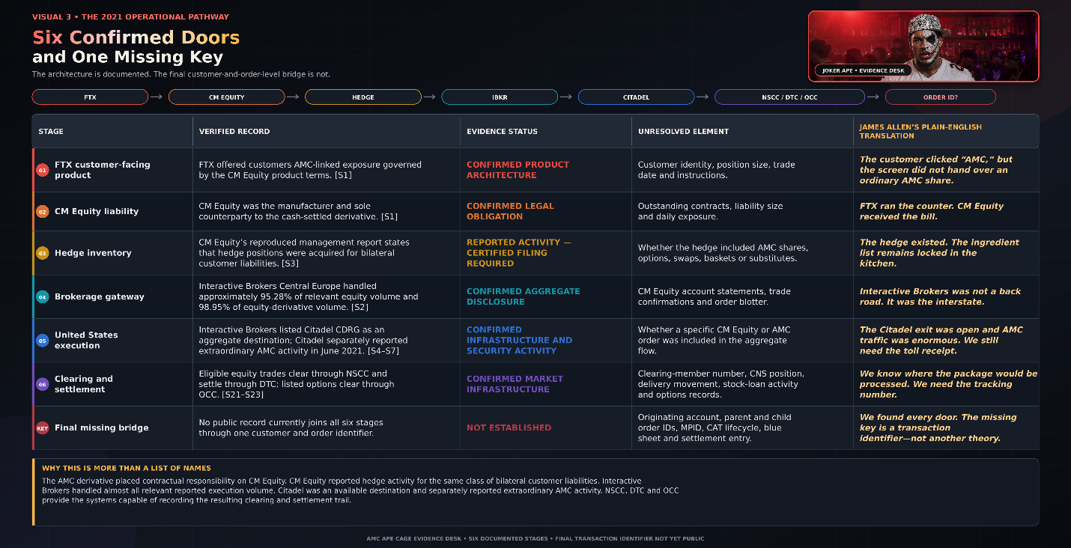
Visual 3 does not show six random names occupying the same financial neighborhood. It shows six distinct functions within a potential transaction lifecycle: customer exposure, legal liability, hedge inventory, brokerage access, execution and settlement. Each stage is supported by a public record. What remains missing is the identifier connecting one specific transaction across all six stages.
That is where the public disclosures reach their limit. Interactive Brokers’ Rule 606 report aggregates routing across customers and securities. Citadel’s Rule 605 report aggregates covered orders by security. Neither report identifies the customer, beneficial owner, originating account, complete routing history, position purpose, long-or-short marking, locate source, derivative liability or collateral agreement.
Matching those reports establishes that the pathway was operational. It cannot manufacture a customer identifier that neither report contains. Two aggregate reports do not become transaction-level evidence simply because their dates and entities align. A percentage cannot be cross-examined, and an aggregate total cannot testify about who submitted a particular order.
The records capable of closing the gap are identifiable. A CM Equity Interactive Brokers trade confirmation could reveal AMC, the originating account, side, quantity, submission time and execution venue. A parent-and-child order history could show whether a larger hedge instruction was divided and routed to multiple destinations. A CAT lifecycle could connect the order’s origination, modification, routing and execution. A blue-sheet response could identify the account and transaction. NSCC records could identify the clearing member and CNS position, while DTC records could show the corresponding securities movement. If listed options were involved, OCC records could identify the contracts, exercises and assignments.
That is the honest evidentiary position. The pathway is documented. The contractual liability existed. Hedge activity was reported for the relevant class of customer obligations. Interactive Brokers was the dominant gateway. Citadel was an available destination and separately reported extraordinary AMC activity. The necessary clearing and settlement systems were operational.
What remains missing is the originating account, order identifier, execution MPID and clearing entry that would transform an operational pathway into an attributed transaction. Wall Street may call that a limitation. This report calls it a very specific records request.
With the six-stage architecture established, the next section leaves the map behind and examines the traffic itself: Citadel’s June 2021 AMC covered-order totals, the T-plus-2 settlement calendar, the failure-to-deliver cluster and the dates that transaction-level records must finally explain.

Apparently, the Calendar Forgot to Name the Defendant: AMC’s Price, FTDs and the T-Plus-2 Settlement Trail
This section places AMC’s June–July 2021 price history beside its aggregate failures to deliver, the T-plus-2 settlement calendar and Regulation SHO’s closeout requirements. The dates establish sequence, overlap and investigative relevance. They do not identify the clearing member, broker, customer or transaction responsible for a failed delivery. Apparently, the calendar agreed to testify but refused to name the defendant.
All prices and share quantities use AMC’s pre-reverse-split 2021 basis. The SEC figures represent aggregate NSCC Continuous Net Settlement FTD balances associated with AMC on each settlement date. They are not counts of newly failed trades, they are not cumulative totals, and they are not Citadel-specific. The public data also do not reveal whether a failure originated from a long sale, short sale, market-making activity, delayed customer delivery, an unavailable borrow or another settlement problem. [S8–S9]
That limitation does not make the figures meaningless. Millions of unresolved shares document substantial settlement stress and identify dates that deserve reconstruction through member-level and transaction-level records. The limitation is attribution, not relevance.
The chronology begins on May 28, 2021, when the CM Equity AMC product document established the FTX-linked instrument as a bilateral, cash-settled derivative. [S1] It does not disclose the number of customer contracts, an AMC hedge position or where any hedge orders were executed. May 28 is therefore the contractual anchor, not proof of a particular trade.
On June 1, AMC closed at $32.04 with 1,799,143 aggregate FTDs. AMC also issued 8.5 million shares to Mudrick Capital, creating legitimate new supply and settlement activity that must be included in any reconstruction. [S11] On June 2, AMC reached $72.62 intraday and closed at $62.55, approximately 95.2 percent above the previous close. The aggregate FTD balance was 1,259,609 shares.
On June 3, AMC completed an 11.55 million-share ATM offering at an average price of $50.85, raising approximately $587.3 million. [S10] The same settlement date carried 5,448,460 aggregate FTDs, the largest balance in this selected chronology. That overlap is significant, but it does not prove that the ATM caused the failures or that any particular market maker carried them. “Beside” and “because of” remain different phrases, even on Wall Street.
June 4 was the ordinary T-plus-2 settlement date for June 2 trades. AMC closed at $47.91 with 1,402,677 aggregate FTDs. That balance cannot be assigned exclusively to June 2 because it could contain older unresolved obligations, new failures and positions resolved through delivery, borrowing, purchases or netting. The public file does not disclose the age or origin of each failed obligation.
Settlement pressure returned later in June. Aggregate FTDs rose from 2,333,859 on June 18 to 4,053,113 on June 21 and 4,419,417 on June 25 while AMC continued trading above $54. AMC also appeared on the NYSE threshold securities list. Threshold status confirms persistent settlement failures sufficient to meet Regulation SHO’s criteria, but it does not identify the responsible participant or automatically prove abusive naked short selling. A participant-level fail persisting for 13 consecutive settlement days can trigger Rule 203(b)(3)’s additional closeout requirement, but determining whether that occurred requires records unavailable in the public aggregate file. [S9]
Fails remained above four million on June 30 and above 3.5 million on July 1 before collapsing to 41,296 on July 6 and 9,058 on July 7. July 6 was exactly 34 calendar days after June 2. AMC closed at $49.96, which was 20.1 percent below the June 2 close and 31.2 percent below its intraday high. AMC had not been cut in half within 34 days.
The first close below half of the June 2 intraday high occurred on July 14, when AMC closed at $33.43. That was a decline of 46.6 percent from the June 2 close and 54.0 percent from the intraday high, occurring 42 calendar days later. The actual decline was already severe. It does not need an incorrect timeline glued to it with ape-strength duct tape.
Visual 4 places these contractual, corporate, price and settlement events on the same calendar. It shows what overlapped, what followed what and where the public evidence stops.
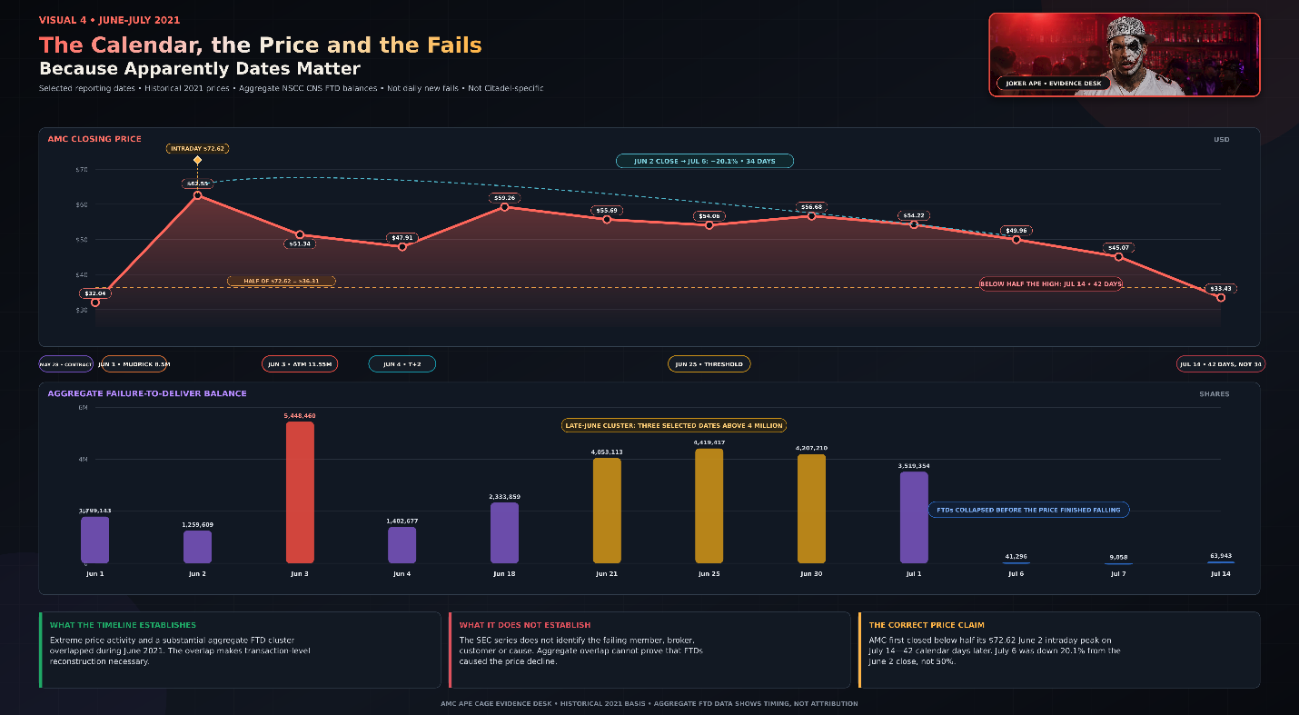
The largest late-June FTD balances occurred while AMC continued trading mainly in the mid-$50s. By July 6 and July 7, the aggregate FTD balance had collapsed dramatically, yet AMC’s price continued falling and reached $33.43 on July 14. That timing does not eliminate the possibility of manipulation. It prevents the public FTD series from proving a one-step causal story in which one unresolved delivery balance mechanically drove the stock from $72.62 to $33.43.
This is where T-plus-2 and Rule 204 must be explained correctly. T-plus-2 was the ordinary deadline for completing the trade, not a guaranteed deadline for publicly revealing who failed. If shares were not delivered by settlement, Regulation SHO imposed closeout requirements based on the type of transaction.
For a short-sale failure, Rule 204 generally required the clearing participant to close the position by borrowing or purchasing securities no later than the beginning of regular trading on the settlement day following the settlement date. For a long-sale failure or a failure attributable to bona fide market-making activity, the rule generally allowed until the beginning of regular trading on the third consecutive settlement day following settlement. [S9]
The frequently repeated “35-day market-maker exemption” is not an accurate description of the rule. The limited 35-calendar-day period applied when the failed position resulted from the sale of a security the seller was deemed to own and intended to deliver after restrictions preventing delivery were removed. A common example involves restricted securities awaiting removal of transfer restrictions. It was not a universal 35-day grace period for market makers, short sellers or anyone who found the ordinary delivery deadline inconvenient. [S9]
The distinction matters because an aggregate FTD balance can change for several reasons. Older obligations may be delivered or closed. New failures may enter the balance. Transactions can be netted through CNS. Shares can be borrowed, purchased or transferred. A declining balance does not tell the public which participant cured an old fail, whether another participant created a new one or what trading activity accompanied the change.
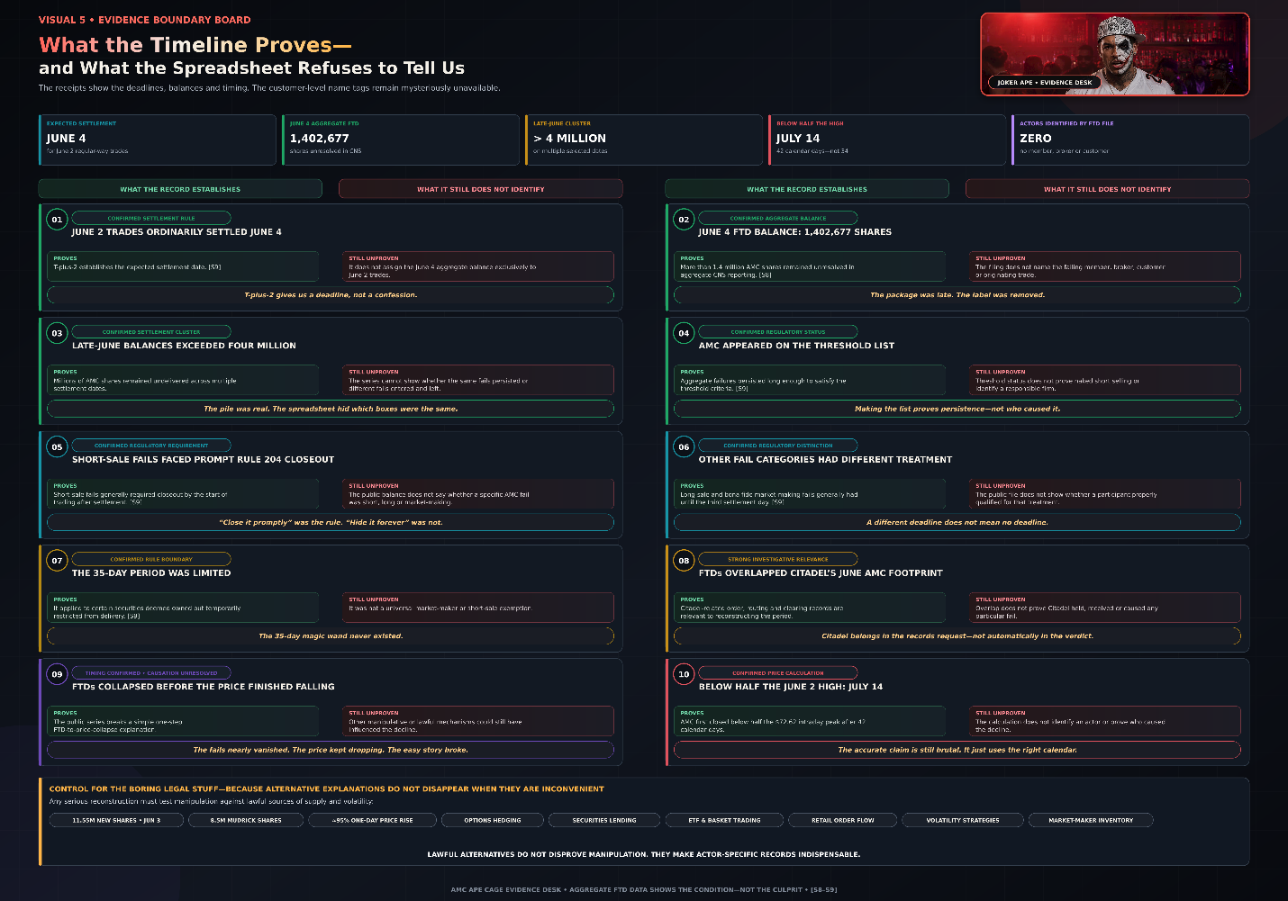
The existence of those alternatives does not prove that manipulation did not occur. It means the actor-specific records are indispensable. A credible analysis must separate legitimate supply, legitimate hedging and ordinary settlement problems from activity designed to create artificial supply, conceal exposure or manipulate price. That separation cannot be performed with an aggregate FTD file and a price chart alone.
The records required include NSCC member-level CNS positions, DTC participant movements, stock-loan records, closeout purchases, buy-ins, allocation files, order-level CAT data, blue sheets and the relevant broker account statements. Those records would show which member owed delivery, when the obligation originated, how long it remained open, whether it was long or short related, how it was resolved and whether the associated trading reached Citadel.
The exact price statement must therefore remain disciplined:
“AMC fell below half of its June 2 intraday peak by July 14, after a period of extraordinary covered-order volume and a substantial aggregate failure-to-deliver cluster.”
That statement does not claim the FTD cluster caused the decline. It does not assign every fail to Citadel. It does not pretend AMC fell by half within 34 days. It puts the verified price, execution and settlement events on the same calendar and identifies the records necessary to determine whether they were connected.
The calendar has now done everything a calendar can do. It has established the dates, corrected the percentage claim and identified the investigative windows. What it cannot do is tell us who submitted the orders.
That question moves the report into the next section, where Citadel’s own June 2021 Rule 605 file finally takes the witness stand.

Apparently, 1.611 Billion Covered Order Shares Were Easy to Count but the Driver and the Modern Token Receipt Remained Mysteriously Unavailable
This is where the investigation must perform two jobs at once without allowing either one to corrupt the other. The first job is historical: measure Citadel Securities’ documented AMC covered order footprint during June 2021 and identify precisely what that record establishes. The second job is comparative: examine the modern Ondo, Alpaca and Citadel infrastructure to determine whether the financial mechanics proposed in this investigation actually exist in an operating tokenized equity market.
The comparison is legitimate. Merging the two periods is not.
Citadel’s June 2021 Rule 605 report and the modern Ondo structure answer different questions. The Rule 605 file establishes that Citadel handled extraordinary AMC covered order volume during the month under investigation. The modern structure establishes that a tokenized instrument can create an off chain liability supported through regulated brokerage, custody and execution infrastructure. Neither record identifies a specific CM Equity AMC hedge order, and the modern structure cannot travel backward through time to prove who did what in 2021.
Apparently, even blockchain has not invented a legal time machine. Wall Street will undoubtedly keep working on it.
Citadel’s June 2021 Rule 605 file reports approximately 3.11 million covered AMC orders representing approximately 1.611 billion shares across the full month. Approximately 954.2 million covered order shares were reported as executed at Citadel, approximately 648.4 million were canceled and approximately 8.3 million were executed elsewhere. [S6–S7]
The wording matters. The file reports shares represented by covered orders. It does not say that Citadel purchased, sold or accumulated a proprietary position of 1.611 billion AMC shares. It does not say that 1.611 billion unique shares existed. It does not say that all those shares were executed. It does not say that the activity occurred entirely on June 2. It does not identify whether the originating customer was buying or selling.
Orders may be canceled, replaced, modified, partially filled or routed elsewhere. A single economic trading decision may therefore generate several reportable order events. Rule 605 measures execution quality activity involving covered orders. It is not a position statement, securities inventory, stock loan ledger, short interest report or confession written in spreadsheet form.
That limitation does not make the data unimportant. It tells us what kind of importance the data carry.
Citadel did not merely possess theoretical capacity to execute AMC orders. Its own security specific report documents enormous actual AMC covered order activity during the same month in which AMC experienced extreme price movement, CM Equity’s AMC derivative existed, CM Equity reported acquiring hedge positions for bilateral customer liabilities and AMC developed a substantial failure to deliver cluster. [S1–S8]
The evidence therefore establishes capacity, proximity and activity. Citadel had the infrastructure. Citadel was processing AMC covered orders. The volume was extraordinary. The timing was relevant. Those conclusions are grounded in the public record.
The report does not establish whose activity it was.
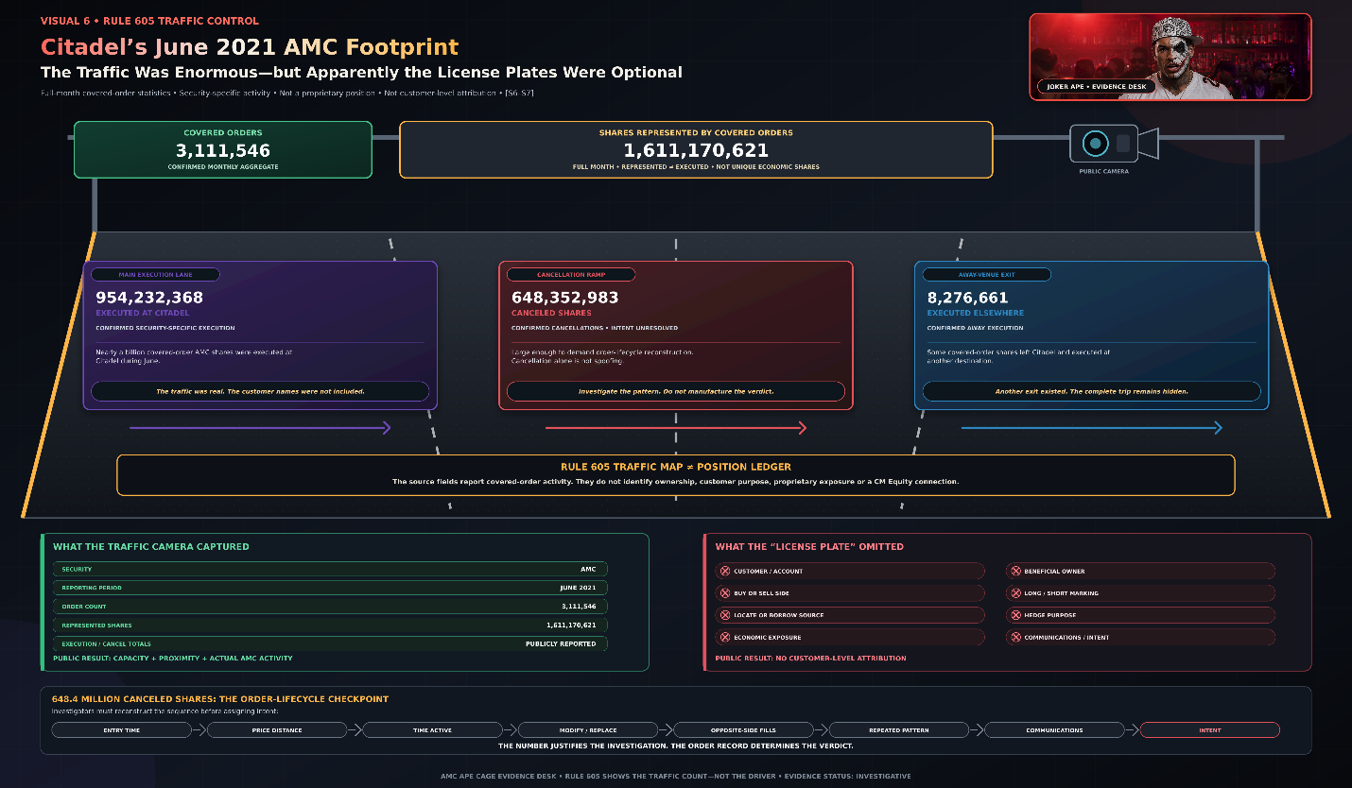
Citadel’s approximately 648.4 million canceled AMC covered-order shares justify reconstructing the underlying order lifecycle: entry time, price, duration, modifications, replacements, opposite-side executions and any pattern creating false supply, demand or liquidity. They do not prove that every cancellation was spoofing. Orders are routinely canceled because prices move, instructions change, partial fills occur, routers change venues, risk limits shift or market makers update quotes. Manipulation requires an identifiable actor, conduct and purpose. [S20] The number tells investigators where to dig. It does not testify under oath.
Rule 605 provides none of the customer-level information needed to connect Citadel’s activity to CM Equity, Interactive Brokers or FTX. Completing that connection requires five categories of proof: actor evidence linking the originating account to the order through confirmations, statements, blue sheets or CAT data; conduct evidence showing order side, price, quantity, timestamps, modifications, cancellations, routes, short markings, locates and executions; settlement evidence identifying the clearing member, NSCC position and DTC movement; economic-link evidence connecting the activity to CM Equity’s AMC liability, hedges, swaps, options, collateral or securities loans; and intent evidence such as communications, instructions or recurring noneconomic patterns. Execution at Citadel does not automatically identify who cleared, carried or failed delivery because trades may clear through another member and be netted before settlement.
Without those records, the public evidence supports a serious transaction-level investigation but does not establish attribution, manipulative intent or a criminal case. Rule 605 gives us the traffic count, not the driver’s license.
The modern Ondo structure provides an operational comparison, not retroactive proof. AMCon is not the 2021 FTX and CM Equity derivative. It is a later product issued through different entities and legal arrangements. Ondo describes its tokenized stocks as structured-note debt issued by bankruptcy-remote Ondo Global Markets BVI Limited. Their value tracks the corresponding security, and Ondo states that they are backed one-to-one, plus a buffer, by securities held through a regulated custodial broker-dealer and cash in transit. A security agent holds a first-priority interest in those assets for token holders. [S12–S13] The token holder receives economic exposure but does not directly own AMC shares, appear on AMC’s shareholder register or receive ordinary voting and ownership rights. The blockchain records the token; brokerage accounts, confirmations, routing reports and custody ledgers record the off-chain activity supporting it. The wrapper is visible. The underlying purchaser, broker, venue and custody trail may not be.
Ondo’s Global Markets Alliance identifies Alpaca as providing tokenized-securities brokerage infrastructure. [S14] Alpaca identifies Citadel Securities as an execution partner dating to 2019. [S15–S16] In September 2025, Citadel reportedly received approximately 57.9125 percent of Alpaca’s aggregate held-order flow for other NMS stocks. [S17] That confirms substantial operational access but does not isolate Ondo, AMCon, AMC or a specific hedge transaction. The exit existed, and the modern highway used it extensively. The AMCon license plate remains unverified.
Visual 7 therefore compares operational layers, not identical transactions: the customer instrument, legal obligation, asset or hedge support, brokerage gateway, execution access and missing transaction-level proof. One pathway is an unresolved 2021 investigation. The other demonstrates that similar off-chain infrastructure operates today.
Two token eras. One off-chain reality. Completely different burdens of proof.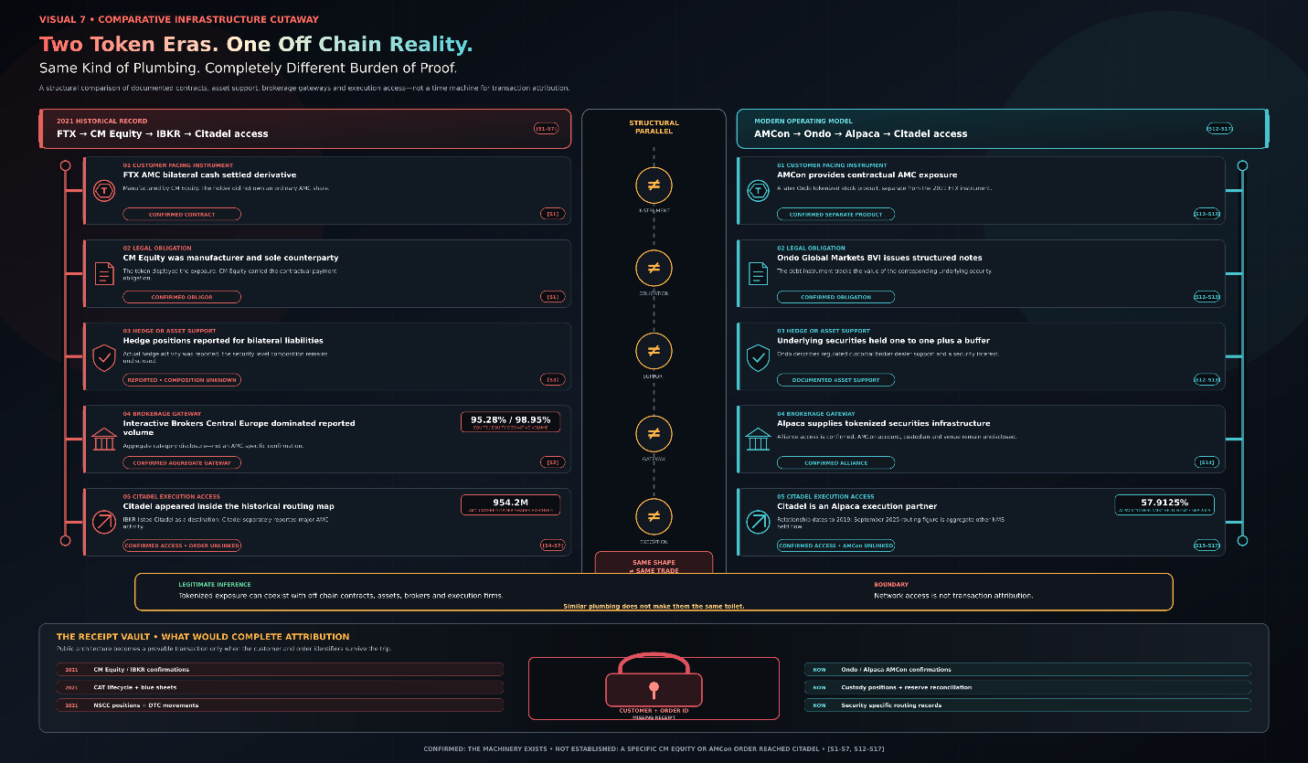
What this comparison cannot do is identify a 2021 transaction. It cannot prove that Citadel executed CM Equity’s AMC hedge, received AMCon-related AMC orders, accepted FTX or Ondo exposure as collateral or participated in a continuous product running from FTX to Ondo. Network access is not customer-level attribution, and a modern structure cannot retroactively prove historical conduct.
What the evidence does establish is substantial. Citadel’s June 2021 Rule 605 data document extraordinary, security-specific AMC activity involving approximately 1.611 billion covered-order shares. The FTX and CM Equity records establish a legally real derivative liability and reported hedge activity. CM Equity’s disclosures identify Interactive Brokers as its dominant brokerage gateway. The modern Ondo and Alpaca records demonstrate that tokenized-stock liabilities can operate alongside traditional brokerage, custody and execution networks in which Citadel is a documented participant.
What none of those aggregate records provides is the customer-and-order identifier connecting a specific token liability to a specific Citadel execution. That is not where the investigation fails. It is where the investigation stops guessing.
The remaining proof must come from CM Equity or Interactive Brokers confirmations and account statements, CAT order lifecycles, blue sheets, NSCC and DTC clearing records, custody positions and collateral agreements. Those records could identify who entered the pathway, what they ordered, where it executed, how it settled and who benefited.
The historical record shows where the traffic existed. The modern comparison proves that the machinery is operational. After counting 1.611 billion covered-order shares, identifying the legal liability, locating the broker, confirming the routing exits and mapping the modern tokenized-equity network, the supposedly unreasonable request is still the simplest one:
Show us the transaction identifier.
Wall Street allowed the public to inspect the contract, count the traffic, find the highway, locate the exits and watch the settlement smoke. But the moment anyone asks whose vehicle actually drove through, suddenly transparency needs a lawyer, three confidentiality agreements and a regulatory blackout curtain.
That is where the evidence desk ends, Joker Ape takes the microphone and the polite part of this report is officially over.
Joker Ape’s Final Word is next and he is done asking nicely.

Joker Ape’s Final Word: I’m Fucking Pissed
Joker Ape’s final word is simple: I am pissed off, not because this investigation failed to produce a clean headline or because I could not force the data into a predetermined conclusion, but because the financial system clearly recorded the product, the liability, the brokerage routing, the execution activity, and the settlement failures, while simultaneously denying the public the identifiers needed to connect those pieces into a complete chain of accountability.
When I began this investigation, I was trying to answer a single question: whether financial exposure created by an AMC linked tokenized product could leave a blockchain environment and enter the traditional brokerage, execution, and settlement system. Based on the public record, the answer is yes in principle, because the structure and infrastructure necessary for that pathway demonstrably existed and were operational.
The FTX linked AMC product was not a direct shareholding arrangement but a bilateral cash settled over the counter derivative issued through CM Equity, where CM Equity acted as the sole contractual counterparty. In that structure, the customer did not hold actual AMC shares but instead held a contract that tracked AMC’s price, meaning the exposure was synthetic rather than direct ownership. CM Equity then reported acquiring hedge positions tied to liabilities arising from these customer contracts, although the available disclosures do not specify the exact composition of those hedges or confirm whether AMC was included, leaving a critical gap in transparency that should be resolved through certified regulatory filings.
CM Equity’s best execution disclosures further show that Interactive Brokers Central Europe handled the overwhelming majority of its relevant equity and equity derivative flow, making Interactive Brokers the dominant operational gateway for the types of transactions that would logically include hedging activity. While this does not prove that any specific AMC hedge was routed through Interactive Brokers, it does establish that Interactive Brokers was structurally positioned as the primary conduit for the relevant category of financial activity.
Interactive Brokers’ Rule 606 reporting also identifies Citadel as a destination within the broader category of routed equity order flow that includes AMC. During June 2021, Citadel accounted for a small but measurable portion of that aggregated routing flow. This again does not prove a direct CM Equity to Citadel connection for AMC, but it confirms that Citadel was an active endpoint within the routing ecosystem during the exact period in question.
Citadel’s own Rule 605 data then provides the most concrete execution level snapshot, reporting over 3.1 million covered AMC orders representing approximately 1.611 billion shares in aggregate order volume for June 2021. Within that dataset, approximately 954 million shares were executed at Citadel, approximately 648 million shares were canceled, and a smaller portion was executed elsewhere. It is critical to state clearly that the 1.611 billion figure represents cumulative shares within covered orders, not unique shares, not net positions, and not proprietary holdings. Rule 605 data does not identify customers, beneficial owners, trade intent, or whether orders were long, short, hedged, or arbitraged.
What this data does establish, however, is scale and intensity. Citadel processed an extraordinary volume of AMC related order activity during the same period in which CM Equity reported hedge activity and AMC experienced significant settlement stress. That combination establishes proximity and relevance, but it does not establish ownership of intent or identify the originating actors behind the flow.
The cancellation volume, approximately 648 million shares, is equally important but must be interpreted carefully. Order cancellations alone do not prove manipulation, as cancellations can result from normal market behavior such as price movement, partial fills, routing optimization, or liquidity adjustments. However, the scale of cancellations does justify deeper forensic reconstruction using full order lifecycle data, including timestamps, modifications, routing paths, and execution intent, because only that level of detail can distinguish legitimate market activity from potentially abusive patterns.
Settlement data adds another layer of concern. AMC experienced persistent failure to deliver balances during June 2021, including spikes exceeding one million shares and later surpassing four million shares, resulting in its appearance on the NYSE threshold list. These figures confirm unresolved settlement obligations within the system, but they do not identify which broker, clearing member, or customer was responsible, nor do they isolate whether the cause was short selling, operational delay, or other settlement friction.
The consistent theme across all of this data is visibility without attribution. The public can see volumes, flows, failures, and routing destinations, but cannot see the underlying customer level identifiers that would allow definitive attribution of responsibility. That is the core frustration: the system is capable of tracking everything, yet the publicly available layer removes the very fields needed to determine who did what.
Modern tokenized equity structures such as those associated with Ondo and brokerage infrastructure like Alpaca further demonstrate that hybrid systems already exist where blockchain based exposure is paired with off chain custody, execution, and settlement. Citadel’s role as a documented execution partner within that ecosystem reinforces the reality that traditional market infrastructure and tokenized financial products are already interconnected in practice, even if the specific 2021 FTX structure is not directly linked to those modern arrangements.
What this proves is not wrongdoing, but feasibility. It shows that a customer facing token can exist on chain while the actual financial machinery, liquidity provision, hedging, execution, custody, and settlement operates entirely off chain within regulated institutions. The blockchain records the wrapper, while the traditional system holds the underlying financial reality.
My conclusion is therefore deliberately narrow. The evidence establishes a plausible and testable pathway connecting tokenized exposure, brokerage routing, execution activity, and settlement stress. It does not establish criminal liability, and it does not identify a guilty party. That distinction matters, because drawing conclusions beyond what the data supports would undermine the integrity of the investigation itself.
A criminal or regulatory determination would require full access to order level data, including customer identifiers, trade intent, routing decisions, hedge instructions, securities lending records, NSCC and DTC settlement files, and internal communications. Those are the records that can confirm or disprove manipulation, spoofing, mismarking, or coordinated activity. Without them, any accusation remains incomplete.
That is why Citadel, Interactive Brokers, and CM Equity all belong in the same records request. Not because they are presumed guilty, but because they are structurally embedded in the only documented pathway that connects the derivative liability to the execution and settlement system. Each entity holds a different segment of the missing chain, and without all segments, the full picture cannot be reconstructed.
Security James correctly followed the evidence as far as public data allows, distinguishing between aggregate volume and individual intent, between execution capacity and ownership, and between settlement stress and proven misconduct. That work matters because it prevents the investigation from collapsing into speculation.
But Joker Ape’s final position is this: the system has already shown us the plumbing, the traffic, and the pressure points. What it has not shown us is the driver behind the wheel. And until those records are produced, the story remains structurally incomplete.
We are not missing another theory. We are missing the receipts.

